**OBSTETRICS AND PREGNANCY OUTCOMES IN PREGNANT WOMEN VACCINATED WITH COVID-19 VACCINE AFTER 13 WEEKS OF GESTATIONAL AGE: A PROSPECTIVE COHORT STUDY**

**Chau Ngoc Minh1,2, Tran Ngoc Van Anh1, Dao Thi Hai Yen1, Nguyen Le Duy2, Vu Thi Lan Anh2, Vuong Thi Ngoc Lan2,3, Ho Manh Tuong1,2**

1My Duc Hospital, Ho Chi Minh City, Vietnam

2HOPE Research Center, My Duc Hospital, Ho Chi Minh City, Vietnam

3University of Medicine and Pharmacy at Ho Chi Minh City, Vietnam

**Introduction**

Vaccination has been the most effective strategy against coronavirus 2019 disease (COVID-19). However, given the disruptive nature of the pandemic, vaccines have understandably been approved using expedited assessment processes. Studies on vaccination in pregnant women have shown no increased risk of pregnancy complications, but these had a retrospective design and/or were limited to mRNA vaccines.1-4 Furthermore, data on the comparative impact of different vaccines in this important patient group is lacking.

Based on our experience, we compared pregnancy and neonatal outcomes in Vietnamese women vaccinated against COVID-19 with the Astra Zeneca versus Pfizer-BioNTech vaccines.

**Methods**

Between August 2021 and November 2021, pregnant women were offered vaccination against COVID-19 at around 30-31 weeks of gestation at My Duc Hospital, Ho Chi Minh City, Vietnam. The choice for Astra Zeneca or Pfizer-BioNTech vaccines depended on the availability of the vaccines at the time of vaccination. We prospectively investigated the side effects in the vaccinated pregnant women within 1 week after vaccination and followed their pregnancies till 28 days after delivery.

**Results**

There were 4420 pregnant vaccinated with Astra Zeneca and Pfizer-BioNTech. Out of them, 533 gave birth (266 women in Astra Zeneca group and 267 in Pfizer-BioNTech group). Women receiving Astra Zeneca were slightly older, less often multiparous, less often had conceived spontaneously, and less often (59.7% versus 80.3%) had received two doses. There were more side-effects reported after Astra Zeneca, but they were all mild (Table 2).

Women who received the Pfizer-BioNTech or AstraZeneca vaccine had a similar post-vaccination rate of COVID-19 (8.6% and 6.8%, respectively; p=0.359)

There were more women with high blood pressure after vaccination with Pfizer-BioNTech as compared to Astra Zeneca (both 0.8% versus 0.2%, p=0.03) (Table 3). The proportion of women who delivered low birthweight infants (birthweight <2500 g) was significantly higher in those vaccinated with the Pfizer-BioNTech versus AstraZeneca vaccine (5.3% vs. 2.5%; relative risk 2.1, 95% confidence interval 1.1–4.2; p=0.03). This appeared to be due to a higher rate of growth restricted infants rather than a higher rate of preterm birth (data not shown).

On multivariate analysis that included vaccine type along with maternal age, number of previous pregnancies, type of pregnancy (spontaneous vs. in vitro fertilization) and post-vaccination COVID-19 infection, vaccination with the Pfizer-BioNTech versus Astra Zeneca vaccine during pregnancy was significantly associated with delivering a low birthweight infant (odds ratio 2.65, 95% confidence interval 1.30–5.76; p=0.01).

**Discussion**

Although the data from this prospective cohort study should be considered preliminary due to the relatively small sample size, and lack of randomization and an untreated control group, we found that a higher proportion of women vaccinated with the Pfizer-BioNTech vaccine during pregnancy delivered low birthweight infants compared to those vaccinated with the AstraZeneca product. A recent report of data from a large number of US-based women concluded that there was no overall increased risk for small for gestational age at birth or preterm delivery in vaccinated versus unvaccinated individuals.2 However, our data suggest that all vaccines may not be equivalent in terms of their effect on infant birthweight when given during pregnancy. Nevertheless, vaccination remains an important tool for preventing the substantial maternal morbidity and mortality and neonatal complications associated with SARS-CoV2 infection during pregnancy.5 Overall, additional research is needed to confirm our preliminary data and, in general, more longitudinal follow-up, including evaluation of large numbers of women vaccinated earlier in pregnancy, is necessary to fully understand the maternal, pregnancy, and infant impacts of COVID-19 vaccination during pregnancy.

**Conclusion**

Pfizer-BioNTech and AstraZeneca COVID-19 vaccines are generally safe and well-tolerated among pregnant women. Pfizer-BioNTech is associated with a higher rate of low birth weight compared to AstraZeneca vaccines.

Table 1. Obstetrics and neonatal outcomes between two groups of vaccination

|  |  |  |  |  |  |
| --- | --- | --- | --- | --- | --- |
| **Gestational characteristics** | **Astrazeneca**  **N=441** | **Pfizer**  **N=513** | **RR**  **(95% CI)** | **Between group difference**  **(95% CI)** | **p** |
| Gestational at birth – weeks | 38.44±1.60 | 38.57±1.34 | - | 0.1 (-0.1, 0.3) | 0.176 |
| Singleton |  |  |  |  |  |
| Twin and Triplets |  |  |  |  |  |
| Preterm delivery – n (%) |  |  |  |  |  |
| 20 ≤ to < 28 weeks | 3 (0.68%) | 0 (0%) | - | - | - |
| 28 ≤ to < 34 weeks | 6 (1.36%) | 8 (1.56%) | 1.15 (0.4, 3.28) | 0.2 (-1.52, 1.92) | 0.95 |
| 34 ≤ to < 37 weeks | 28 (6.35%) | 34 (6.63%) | 1.04 (0.64, 1.69) | 0.28 (-3.07, 3.62) | 0.9 |
| Oligohydramnios | 12 (2.73%) | 15 (2.92%) | 1.07 (0.51, 2.26) | 0.19 (-2.11, 2.49) | 0.95 |
| Polyhydramnios | 14 (3.17%) | 23 (4.48%) | 1.41 (0.74, 2.71) | 1.31 (-1.33, 3.95) | 0.381 |
| Being monitored at ICU | 0 (0) | 2 (0.39) | - | - | - |
| Stillbirth | 2 (0.45) | 1 (0.19) | -0.26 (-1.2, 0.69) | 0.43 (0.04, 4.72) | 0.6 |
| Maternal death | 0 (0.00%) | 0 (0.00%) | - | - | . |
| **Neonatal outcomes** |  |  |  |  |  |
| Live-birth weight – grams | 3148.25±376.76 | 3132.10±403.51 | - | -16.1 (-65.9, 33.6) | 0.524 |
| Low birth weight (under 2500g)* | 11 (2.51%) | 27 (5.26%) | 2.1 (1.05, 4.18) | 2.75 (0.12, 5.39) | 0.046 |
| Heavy birth weight (over 4000g)* | 6 (1.37%) | 10 (1.95%) | 1.42 (0.52, 3.88) | 0.58 (-1.25, 2.41) | 0.66 |
| NICU* | 24 (5.45%) | 23 (4.49%) | 0.82 (0.47, 1.44) | -0.96 (-3.95, 2.03) | 0.594 |
| Birth defects | 4 (0.91%) | 4 (0.78%) | 0.86 (0.22, 3.42) | -0.13 (-1.42, 1.17) | 0.95 |

## Mean ± SD, N (%), *Singletons

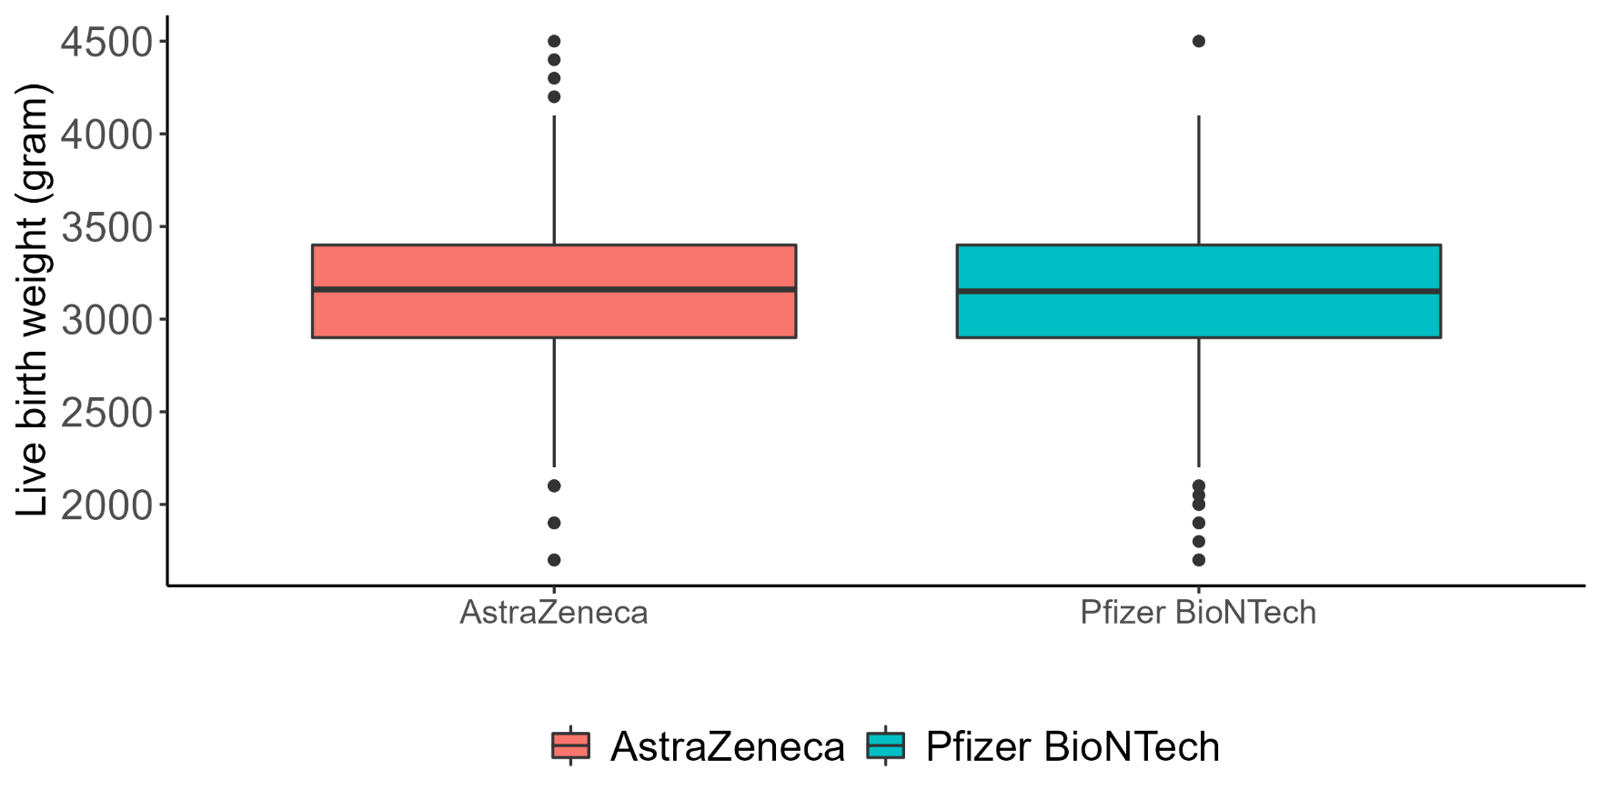

Figure 1. Birth weight of infants from two groups of maternal SARS-CoV-2 vaccination

**References**

1. Shimabukuro TT, Kim SY, Myers TR, et al. Preliminary Findings of mRNA Covid-19 Vaccine Safety in Pregnant Persons. N Engl J Med 2021; 384: 2273-82.
2. Lipkind HS, Vazquez-Benitez G, DeSilva M, et al. Receipt of COVID-19 vaccine during pregnancy and pre-term or small for gestational age at birth—eight integrated health care organizations, United States, December 15, 2020-July 22, 2021. MMWR Morb Mortal Wkly Rep 2022; 71: 26-30.
3. Collier A-RY, McMahan K, Yu J, Tostanoski LH, et al. Immunogenicity of COVID-19 mRNA vaccines in pregnant and lactating women. JAMA 2021; 325: 2370-80.
4. Gray KJ, Bordt EA, Atyeo C, et al. Coronavirus disease 2019 vaccine response in pregnant and lactating women: a cohort study. Am J Obstet Gynecol 2021; 225: 303.e1-17.
5. Villar J, Ariff S, Gunier RB, et al. Maternal and neonatal morbidity and mortality among pregnant women with and without COVID-19 infection: the INTERCOVID multinational cohort study. JAMA Pediatr 2021; 175: 817–826.